**CONTENT OF TABLE**

1) Cover and Title page

2) Synopsis Approval Certificate / S/W Development Company Certificate

3) Index

4) Acknowledgement

5) Certificate of Originality

6) Introduction/Aims and Objective

7) System Analysis

7.1 Identification of Need

7.2 Preliminary Investigation

8) Feasibility Study

8.1 Technical Feasibility

8.2 Economic Feasibility

8.3 Operational Feasibility

9) Analysis (Feasibility Study, DFD 0 Level, 1- Level and 2 Level/ER Diagram, and

Data structure, Table structure etc.)

10) S/W & H/W Requirement Specification

11) Screen Shots

12) Coding

13) Implementation and Maintenance

14) Testing (Testing techniques and Testing strategies, Test cases)

15) Various types of Reports/Modules

16) Future scope of the Project

17) Bibliography/References/Glossary

**Introduction and Objective**

This is real world program which blocks certain distracting website like Facebook, YouTube etc. during your work hours. And also it will block more than 1000+ website containing porn content.

**About the program:** What we are going to in this program is that we will pass the link of websites which you think is distracting and the time that you are working on your computer and program will block those websites. you need to make sure that you have a safe browsing experience.

It doesn’t matter if you like to block a few websites for your safety or would like to provide a productive virtual space for your kids, with a website blocker you can certainly make it happen

This software to block websites will make sure that your kids would remain protected from scams or malpractices on the internet.

The Website Blocker is a freely available software that can help you block any website in no time. Just install and open the application and add the website that you want to block. Furthermore, you can segregate websites on different sets.

**Working of host file:**Host is an operating system file which maps hostnames to IP addresses. In this program we will be mapping hostnames of websites to our localhost address. Using python file handling manipulation, we will write the hostname in hosts.txt and remove the lines after your working hours.

**System Analysis**

**Identification of Need:**

On the [Internet](https://en.wikipedia.org/wiki/Internet), a block or ban is a technical measure intended to restrict access to information or resources. Blocking and its inverse, unblocking, may be implemented by the owners of computers using software. Some countries, [including China](https://en.wikipedia.org/wiki/Internet_censorship_in_the_People%27s_Republic_of_China) and Singapore, block access to certain news information. In the United States, the [Children's Internet Protection Act](https://en.wikipedia.org/wiki/Children%27s_Internet_Protection_Act) requires schools receiving federal funded discount rates for Internet access to install [filter software](https://en.wikipedia.org/wiki/Content-control_software) that blocks obscene content, pornography, and, where applicable, content "harmful to minors".

Blocking may also refer to denying access to a web server based on the [IP address](https://en.wikipedia.org/wiki/IP_address) of the client machine.[[3]](https://en.wikipedia.org/wiki/Block_(Internet)#cite_note-3) In certain websites, including [social networks](https://en.wikipedia.org/wiki/Social_networking_service) such as [Facebook](https://en.wikipedia.org/wiki/Facebook) or editable databases like [Wikimedia projects](https://en.wikipedia.org/wiki/Wikimedia_project) and other [wikis](https://en.wikipedia.org/wiki/Wiki), users can apply blocks

Blocked users may be completely unable to access all or part of a site's content, which is usually the case when censoring or filtering mechanisms are responsible for the block.

**Feasibility Study**

**Technical Feasibility:**

In this program we are blocking websites using Host file. Host is an operating system file which maps hostnames to IP addresses. In this program we will be mapping hostnames of websites to our localhost address. Using python file handling manipulation, we will write the hostname in hosts.txt and remove the lines after your working hours.

**Internet resource blocking:**

Entries in the hosts file may be used to block [online advertising](https://en.wikipedia.org/wiki/Online_advertising), or the domains of known malicious resources and servers that contain [spyware](https://en.wikipedia.org/wiki/Spyware), [adware](https://en.wikipedia.org/wiki/Adware), and other [malware](https://en.wikipedia.org/wiki/Malware). This may be achieved by adding entries for those sites to redirect requests to another address that does not exist or to a harmless destination such as the [local machine](https://en.wikipedia.org/wiki/Localhost).[[12]](https://en.wikipedia.org/wiki/Hosts_(file)#cite_note-12)Commercial software applications may be used to populate the hosts file with entries of known undesirable Internet resources automatically. In addition, user-created hosts files which block nuisance servers are publicly available.

**ER Diagram**

**For 1000+ website:**

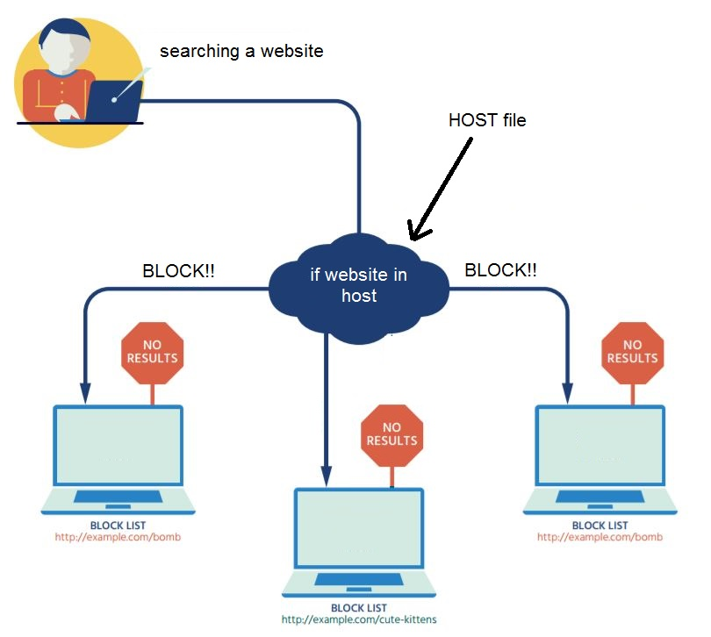

**For input from user:**

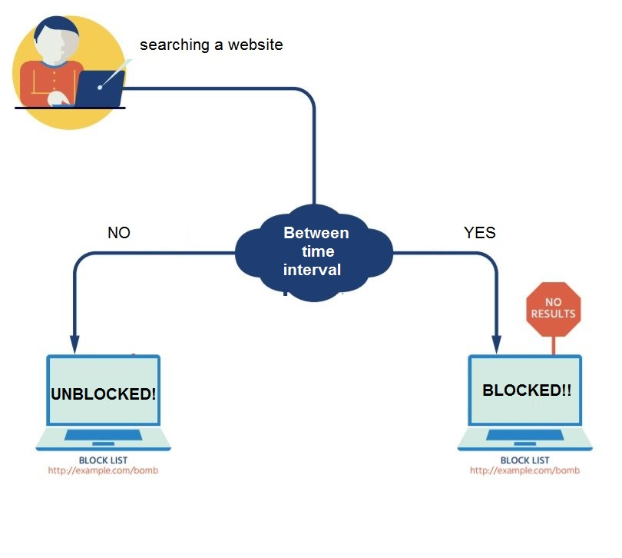

**Hardware / Software Requirement**

**Hardware Requirement:**

Computer : Windows 7 or above

Processor : Intel Core i33.50 GHz or above

Memory : 1GB Ram or above

Hard disk : 10 GB or above [at least 3 MB free space required]

Keyboard

Mouse

**Software Requirement:**

Operating System : window 7 or above

Application Software : Python 3.6.4 or above

System type : 64-bit Operating System

Python Library : Datetime and time library

Editor : Atom/PyCharm etc.

**Screen Shots**

Host File:

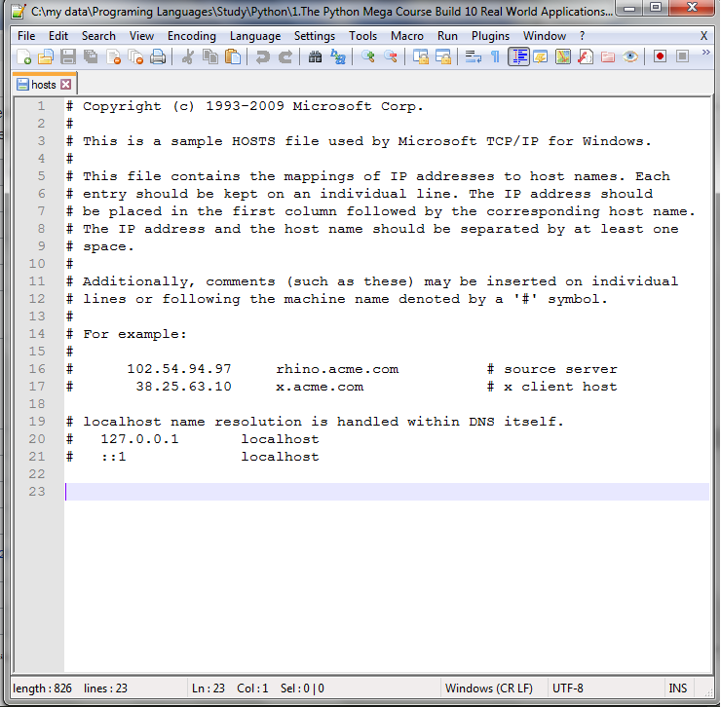

Host file after website blocked:

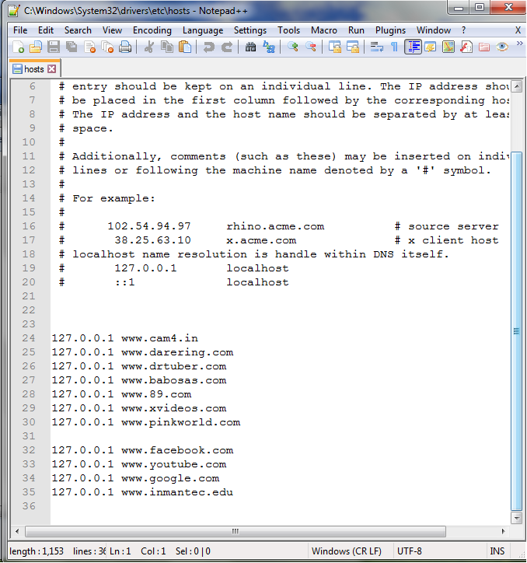

Website Blocked:

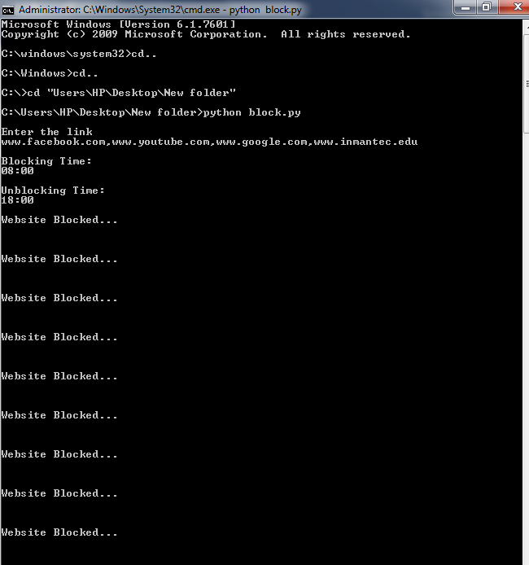

Website Blocked:

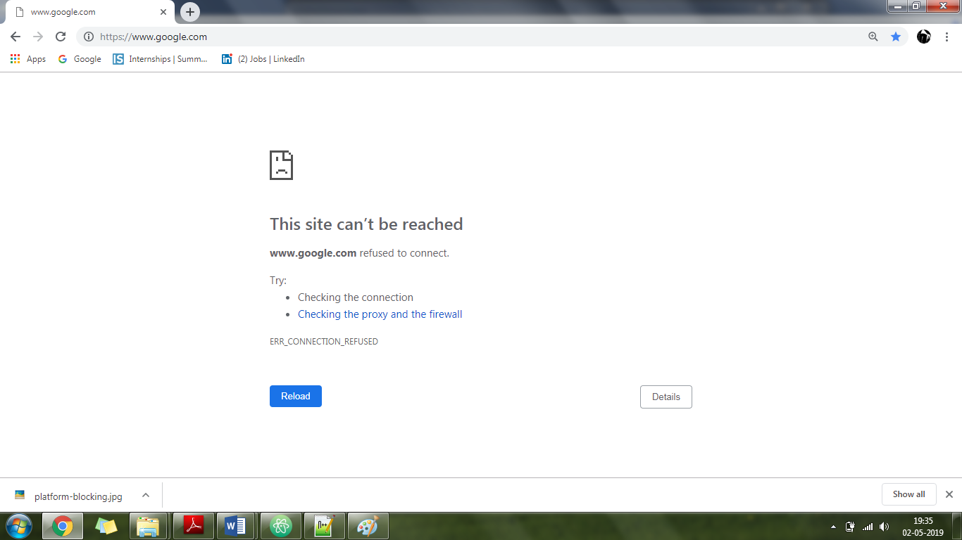

Website Unblocked:

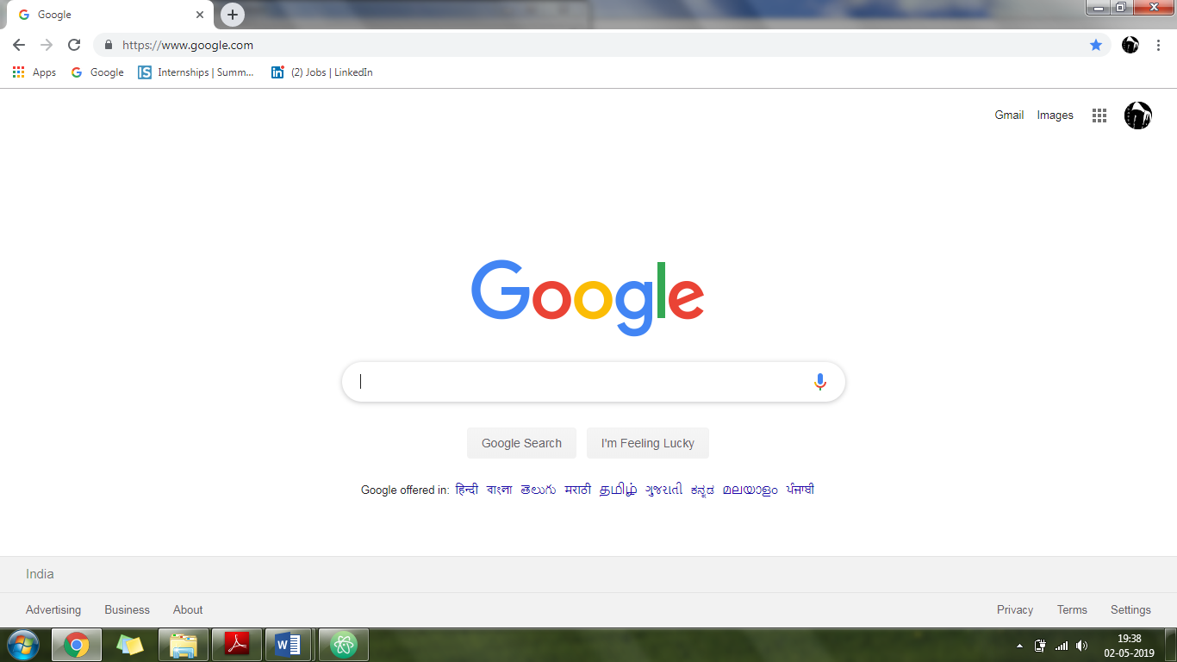

Website Unblocked:

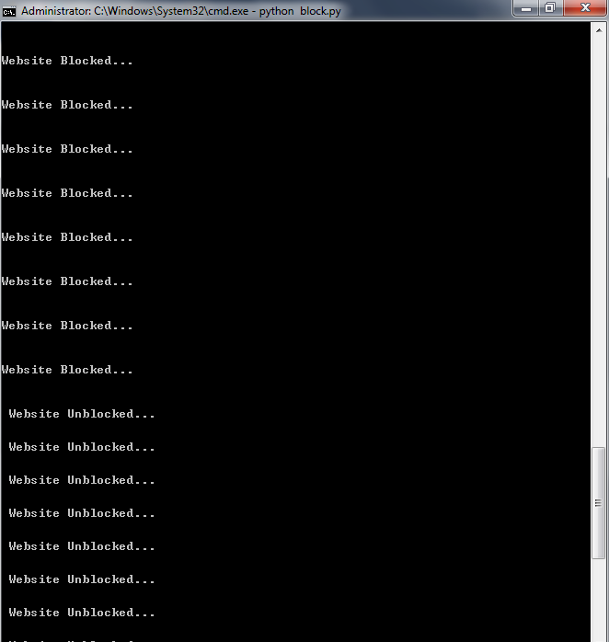

**Coding**

import time

from datetime import datetime as dt

hosts_path=r"C:\Windows\System32\drivers\etc\hosts"

redirect="127.0.0.1"

website_list1='www.cam4.in www.darering.com www.drtuber.com www.babosas.com www.89.com www.xvideos.com www.pinkworld.com'

website_list=website_list1.split()

with open(hosts_path,'r+') as file:

content=file.read()

for new in website_list:

if new in content:

pass

else:

file.write(redirect+" "+ new+"\n")

first=input("\nEnter the link\n")

link=first.split(sep=',')

"\n"

s_hour,s_min=input("\nBlocking Time:\n").split(sep=':')

"\n"

e_hour,e_min=input("\nUnblocking Time:\n").split(sep=':')

while True:

if dt(dt.now().year,dt.now().month,dt.now().day,int(s_hour),int(s_min)) < dt.now() < dt(dt.now().year,dt.now().month,dt.now().day,int(e_hour),int(e_min)):

print("\nWebsite Blocked...\n\n")

with open(hosts_path,'r+') as file:

content=file.read()

for website in link:

if website in content:

pass

else:

file.write(redirect+" "+ website+"\n")

else:

with open(hosts_path,'r+') as file:

content=file.readlines()

file.seek(0)

for line in content:

if not any(website in line for website in link):

file.write(line)

file.truncate()

print("\n Website Unblocked...\n")

time.sleep(5)

**Implementation and Maintenance**

About Python:

Python is an interpreted high-level programming language for general-purpose programming. Created by Guido van Rossum and first released in 1991, Python has a design philosophy that emphasizes code readability, notably using significant whitespace. It provides constructs that enable clear programming on both small and large scales.

History of Python:

Python was conceived in the late 1980s and its implementation began in December 1989[30] by Guido van Rossum at Centrum Wiskunde & Informatica (CWI) in the Netherlands as a successor to the ABC language (itself inspired by SETL)[31] capable of exception handling and interfacing with the Amoeba operating system.[7] Van Rossum remains Python's principal author. His continuing central role in Python's development is reflected in the title given to him by the Python community: Benevolent Dictator For Life (BDFL).

Libraries of Python:

Time:

Python has defined a[module](https://www.geeksforgeeks.org/python-modules/), “time” which allows us to handle various operations regarding time, its conversions and representations, which find its use in various applications in life. The beginning of time is started measuring from **1 January, 12:00 am, 1970** and this very time is termed as “**epoch**” in Python.

Python has a module named time to handle time-related tasks. To use functions defined in the module, we need to import the module first. Here's how:

import time

Datetime:

Python has a module named **datetime** to work with dates and times. Let's create a few simple programs related to date and time before we dig deeper. we need to import the module first. Here's how:

import datetime

One of the classes defined in the datetime module is datetime class. We then used now()method to create a datetime object containing the current local date and time.

Commonly used classes in the datetime module are:

* date Class
* time Class
* datetime Class
* timedelta Class

**Program Architecture:**

1. Every system have host file whether it is Mac, Windows or Linux.

* **Host file in Windows:**C:\Windows\System32\drivers\etc
* **Host file in Linux:**

Linux - */etc/hosts*

* **Host file in Mac OS:**

Mac OS X - */private/etc/hosts*

2. Working of host file**:**

Host is an operating system file which maps hostnames to IP addresses. In this program we will be mapping hostnames of websites to our localhost address. Using python file handling manipulation, we will write the hostname in hosts.txt and remove the lines after your working hours.

This file contains the mapping of IP address to host name. Each entry should be kept on individual line. IP address should be placed in first column followed by the corresponding host name. The IP address and the host name should be separated by at least one space.

For example:

127.0.0.1 [www.google.com](http://www.google.com)

127.0.0.1 [www.facebook.com](http://www.facebook.com)

**Scope of the project**

The scope is everything that needs to be accomplished in order for me to have a successful project. There is a lot to do when creating a project, there are many algorithms and theories and there are different approaches to each one and choosing the right one is vital. This is discussed in more detail in the design section, with justification of each decision.

The purpose for “Website Blocker” is to block all the websites which contains porn content. Today is the era of computers. This software solves all the problems related to accessing all this type of websites. Another main objective of developing this project is to save your valuable time and money.

This Website Blocker Project is:

* Fast
* Effective
* Safe
* User Friendly
* Easy to use

**Bibliography**

Websites:

1. <https://pythonhow.com/>
2. <https://www.google.com/>
3. <https://en.wikipedia.org/>
4. <https://www.udemy.com/>

Books:

1. Python Programming by JOHN ZELLE
2. Learning Python by Mark Lutz